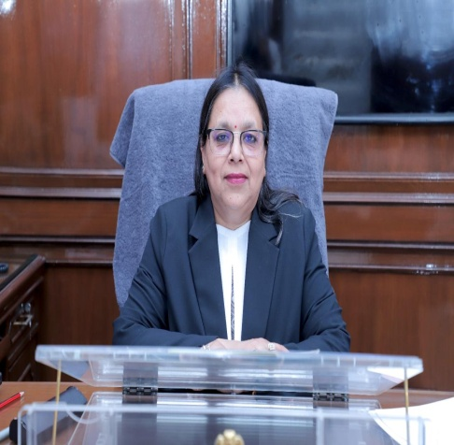

**MS. SHAIL JAIN**

Ld. Chairperson South DLSA